Accessing EC2 instance of Amazon_Linux AMI

Create an instance of your own naming

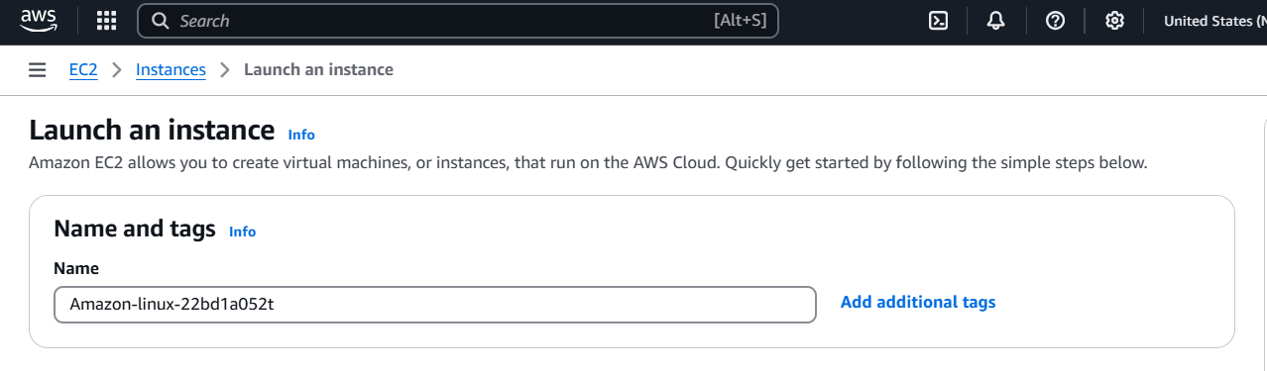

Select Amazon Linux AMI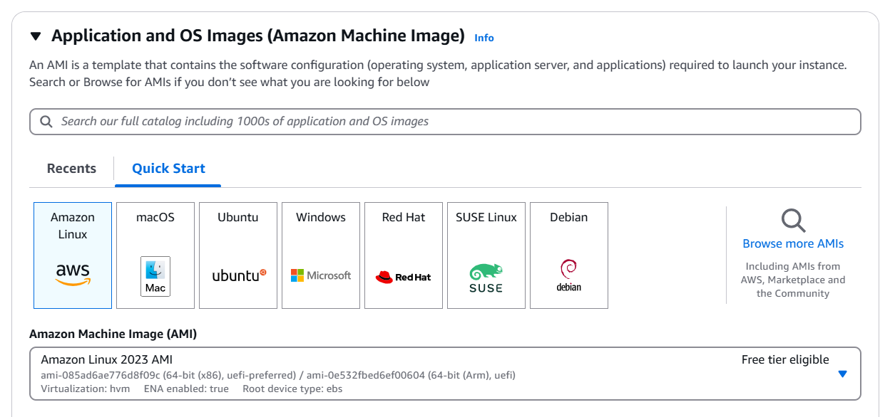

Configure the architecture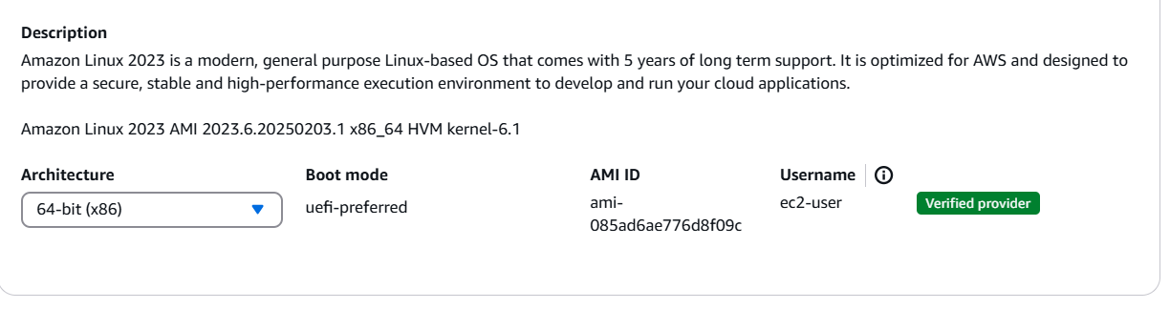

Select the instance type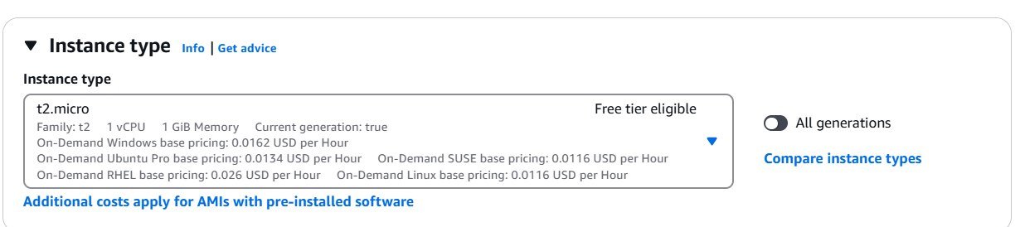

Create a keypair file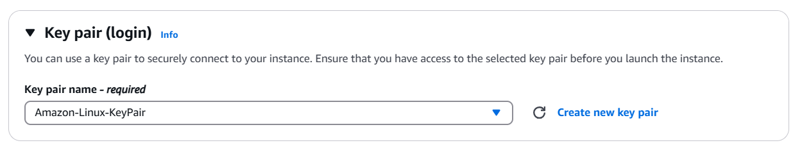

Configure the storage settings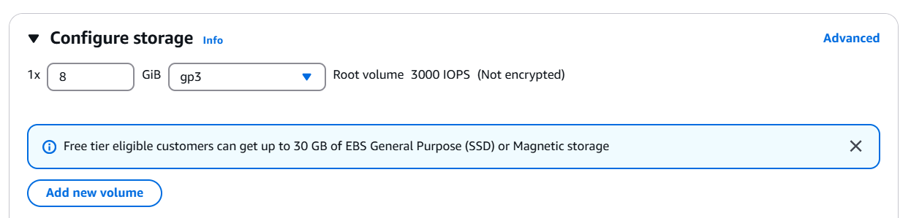

Select number of instances required and launch the instance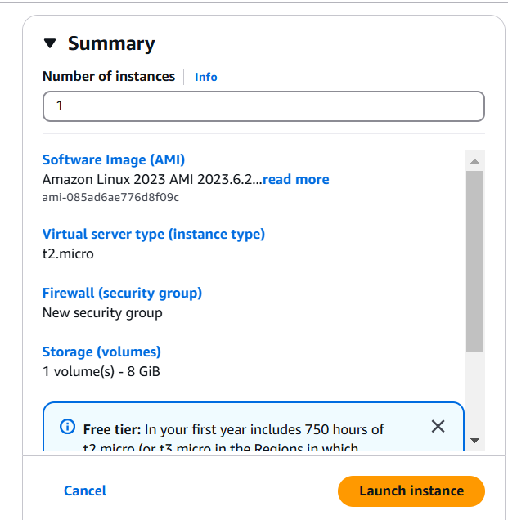

Configure the network settings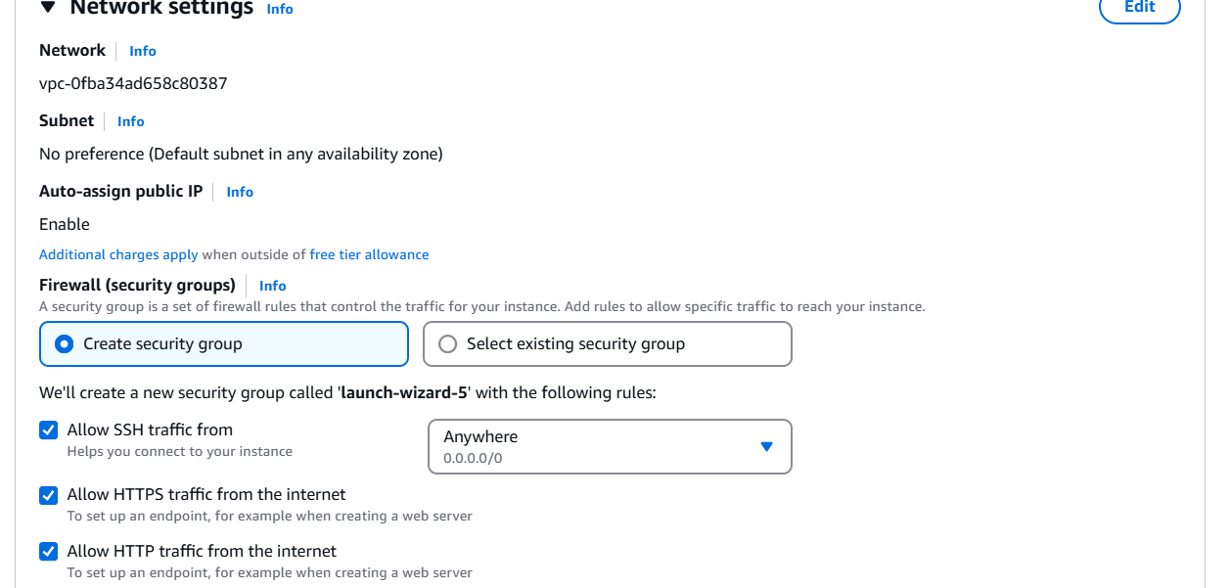

Select the instance created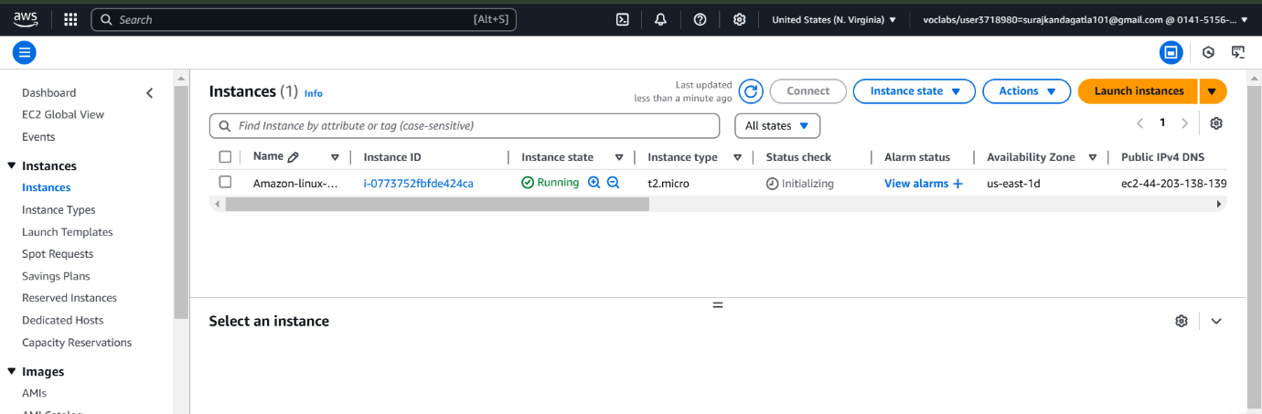

Connect the instance directly using EC2 connect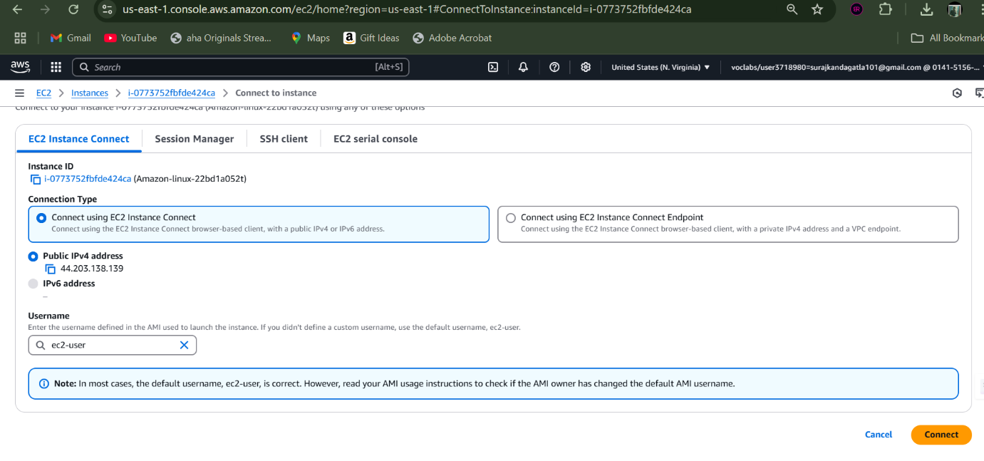

Now we are connected to the Amazon linux AMI instance

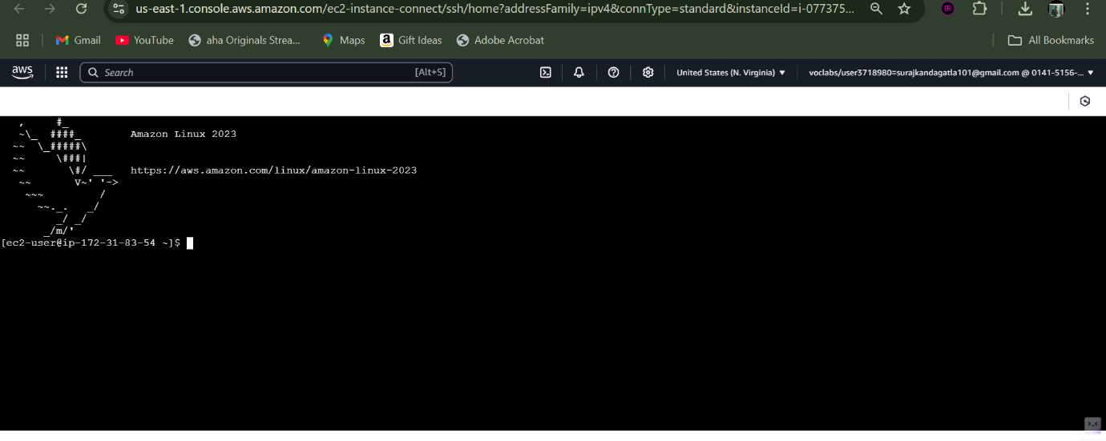

update the instance.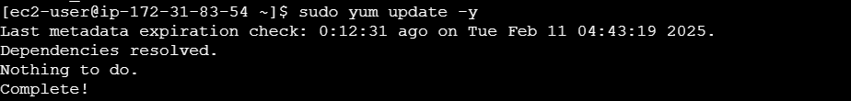

install apache using this command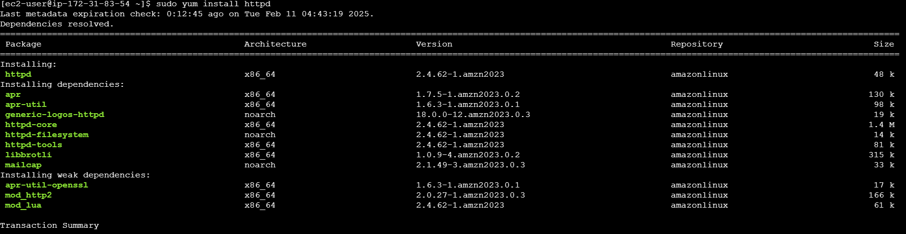

wait until the installation is done.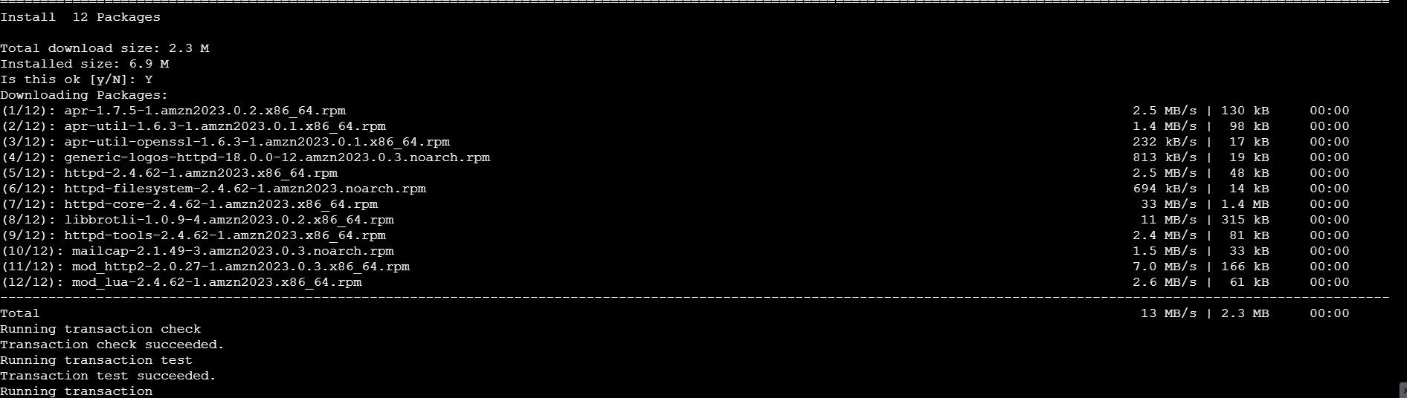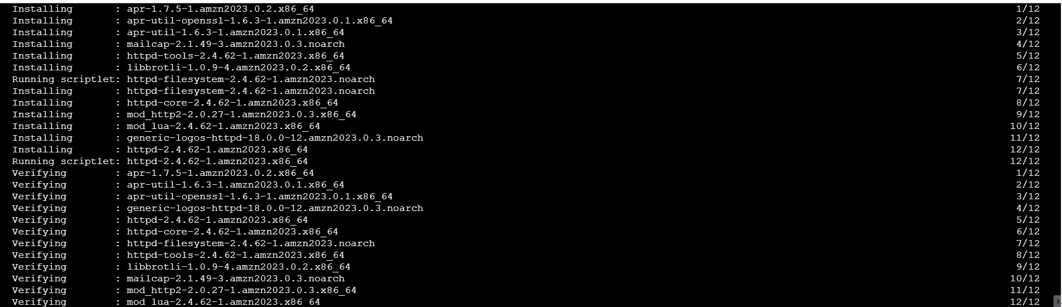

now start the apache server

check the status of the apache whether it is enabled or not.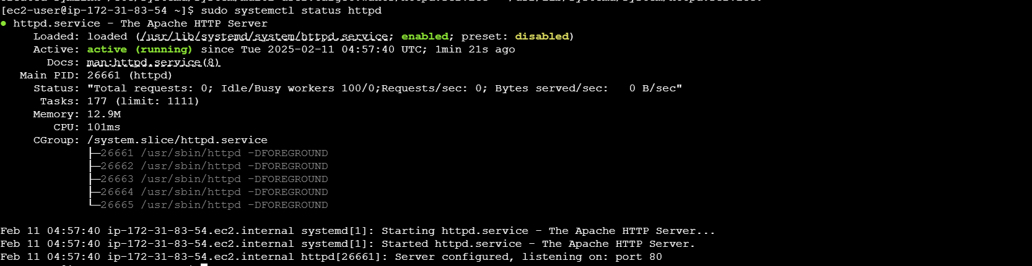

once it is enabled, access the instance using public IPv4 address.